TX-3050SF Servo Flat Screen Printing Machine
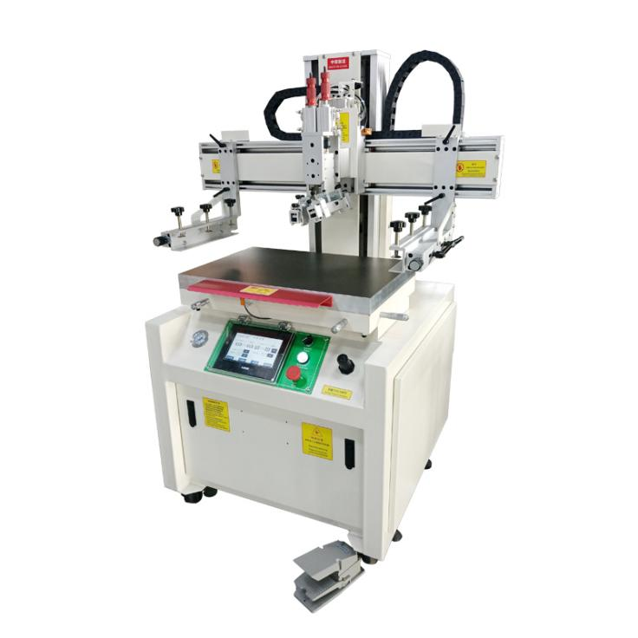 | 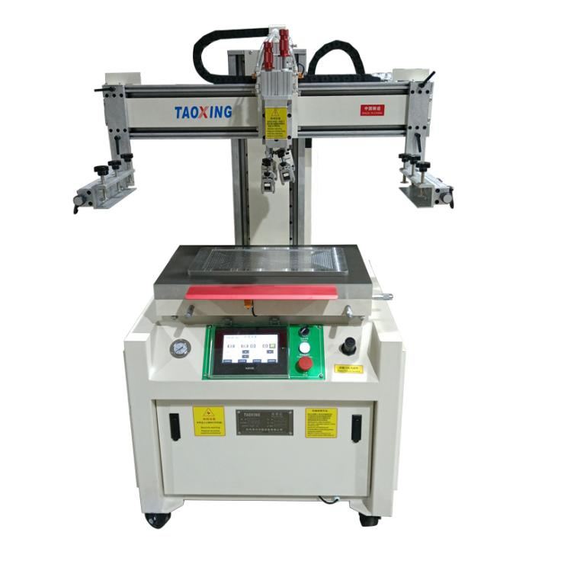
★Scope of application
Suitable for high-precision positioning screen printing of permanent magnets, electronic panels, glass panels, ceramic substrates, metal signs, PCB boards and other products .
- Main parameters
model | TX - 3050SF | Printing area | 300* 500mm
Platform size | 400 * 600mm | Maximum screen frame | 500* 900mm
Printing thickness | ≤ 200 mm | Printing accuracy | ± 0.02mm
Maximum number of idling prints | 1400 (PCS/H) | Printing pressure | 0.5-0.7Mpa
Power supply/power | 220V / 2.0KW | Gross Weight | 230 KG
Machine size | 900*600*1650mm | Packing size | 1100*750*1800mm
★Main performance
①Mitsubishi PLC program control circuit, human-machine interface control, user-friendly operation.
②Vertical structure, the screen moves up and down vertically, and the printing head moves left and right.
③ The printing and screen lifting adopt independent driving sources, with coordinated movements and stable and adjustable speed.
④The Panasonic servo system drives the printing tool holder, the photoelectric eye controls the stroke and is adjusted independently.
⑤ Printing drive Panasonic servo motor, smooth operation.
⑥ The printing platform is equipped with precision fine-tuning handles in the horizontal and vertical directions, which enables accurate fine-tuning and convenient color registration.
⑦ There are three printing modes: manual/semi-automatic/fully automatic. The automatic printing time is digitally controlled (1~9 seconds).
⑧ Independently designed machine head lifting device, ink scraper/ink return knife, screen loading and unloading and screen cleaning are convenient.
⑨ The left and right screen clamp arms are equipped with plate spacing adjustment devices for easy adjustment.
⑩The angle and balance of scraping and ink return can be adjusted.
⑪The printing table adopts a vacuum suction work surface to facilitate the fixing of printing sheets .
★ Details display
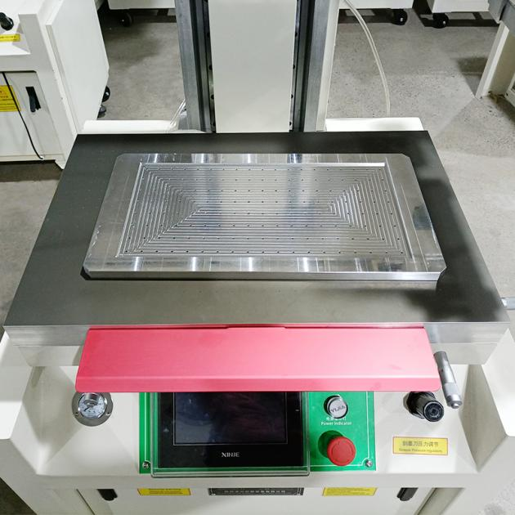 | 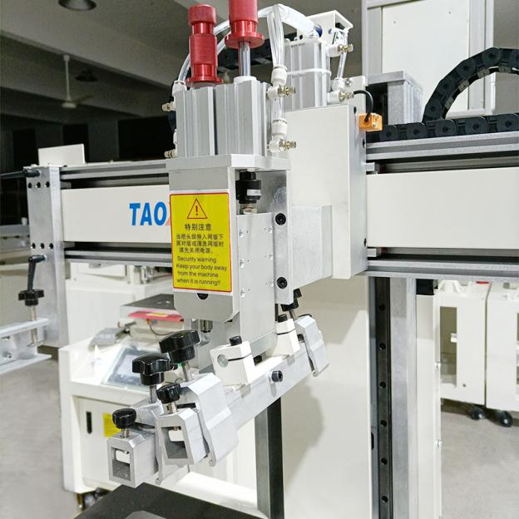
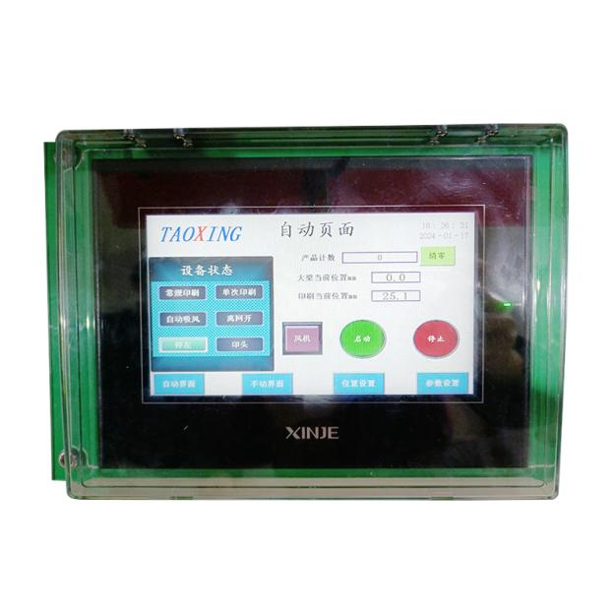 | 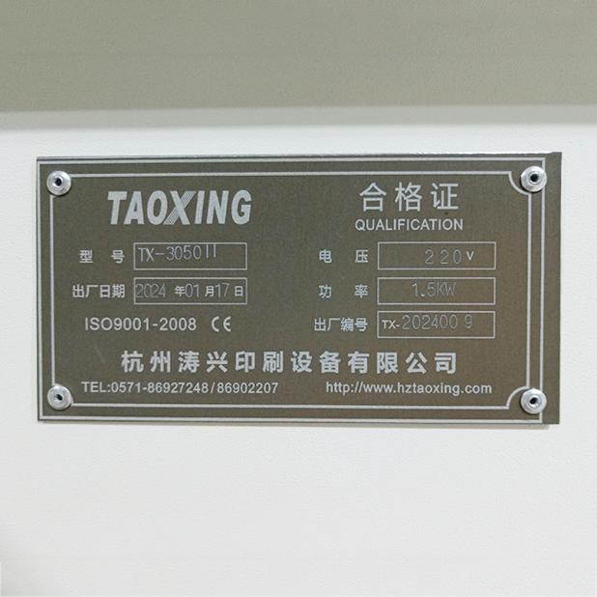
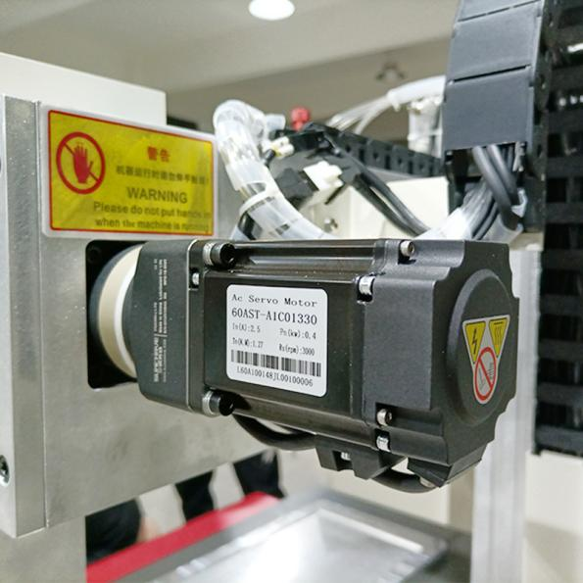 | 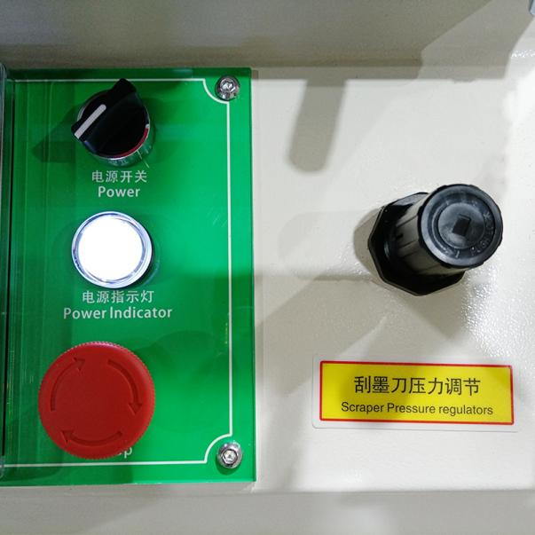
★ Touch screen operation interface
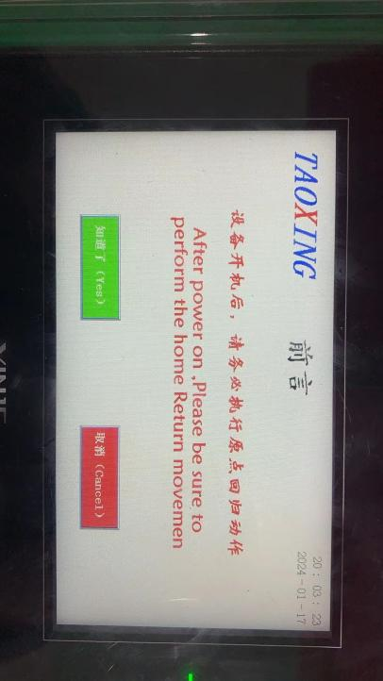 | 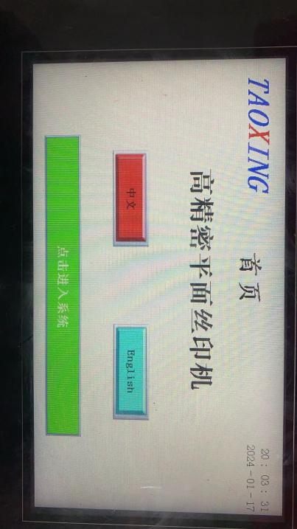
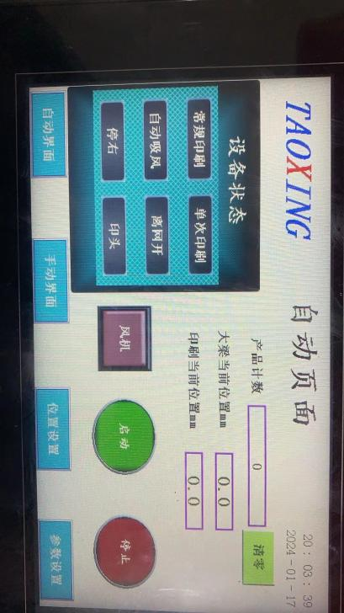 | 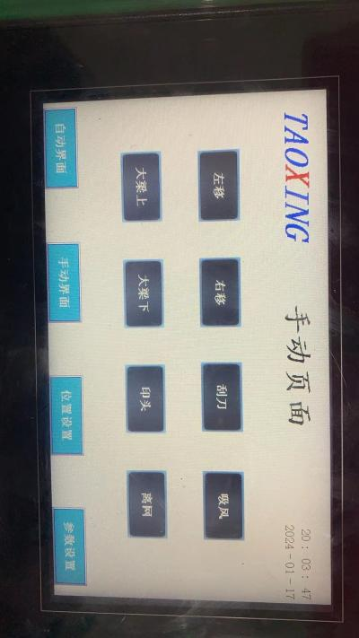
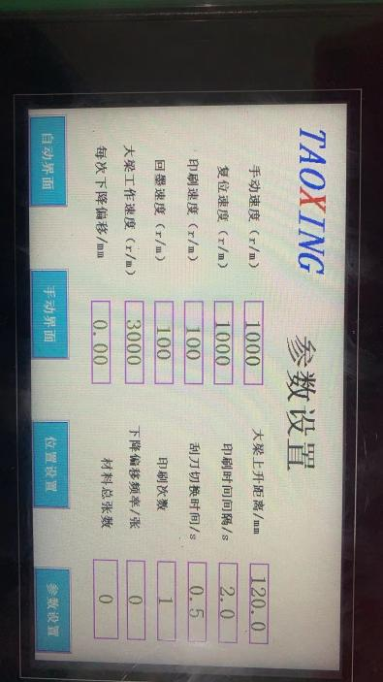 | 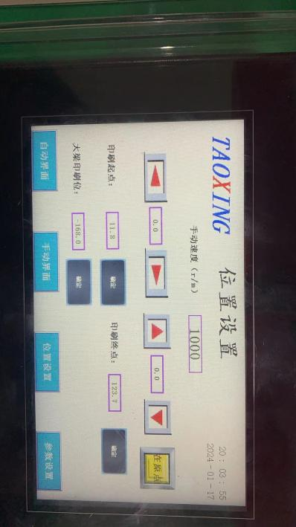
★Configuration list
Structure | project | Configuration Instructions
Basic structure | structure | Vertical | /
Basic structure | frame | Steel structure welding | self made
Basic structure | beam | A3 Steel Plate | self made
Basic structure | Sliding Bushing | Aluminum Alloy | self made
Basic structure | Linear square guide shaft | Linear square guide shaft | Taiwan Hiwin Guide Shaft
Basic structure | Base | Cast iron base | self made
Rack lifting | Lifting drive | Motor | Taiwan Beiji reducer motor
Rack lifting | Lifting guide | Linear square guide shaft | Panasonic Servo Motor
Printing Drag | Printing driver | Servo System | Panasonic Servo System
Printing Drag | Printing Guide | Linear square guide shaft | Taiwan Hiwin Guide Shaft
Shelf system | Screen clamping | Mechanical combination | Aluminum handle
Shelf system | Off-grid systems | none
Shelf system | Ink scraping system | pneumatic | SMC Cylinder
Platform system | Inhale | have | Vacuum adsorption work surface
Platform system | Platform fine-tuning | Suction work surface | Scale display precision fine adjustment
Control System | Control Circuit | Taiwan Fengwei PLC | Can be printed multiple times.
Control System | Electrical components | Foreign famous brands | Omron relay, Schneider contactor, HLW induction switch
Control System | Pneumatic components | Solenoid valve | E-day solenoid valve and oil-water separator
Safety devices | Safety brake | Proximity switches | Red oxide brake pads
★ Delivery list
Serial number | Tool Name | Specification | unit | quantity | Remark
1 | Power cord | Standard | root | 1
2 | Foot switch | Standard | indivual | 1
3 | Phillips screwdriver | Standard | Bundle | 1
4 | Adjustable wrench | Standard | Bundle | 1
5 | Hexagon socket wrench | Standard | set | 1
6 | Toolbox | Standard | indivual | 1
7 | User Manual |  | Book | 1
- After-sales service instructions
- support for all factory products .
- After installation and commissioning, free warranty for one year (excluding wearing parts and man-made damage) and lifelong maintenance.
- Conduct maintenance visits, on-site operations and technical training at irregular intervals.
- After-sales service content:
  - If the equipment fails, we will first communicate by phone. If the problem cannot be solved, our company will arrive at the site as soon as possible to solve it.
  - After-sales service includes not only equipment repair and maintenance, but also dedicated support for process technology. Our technicians can conduct on-site technical training and provide a full set of screen printing process technology, information and equipment solutions.
  - Professional technicians visit from time to time to track the usage of user equipment.
  - Repair and maintenance of screen printing equipment and auxiliary equipment.
  - Design and customize special product screen printing equipment and auxiliary equipment.
Corporate image
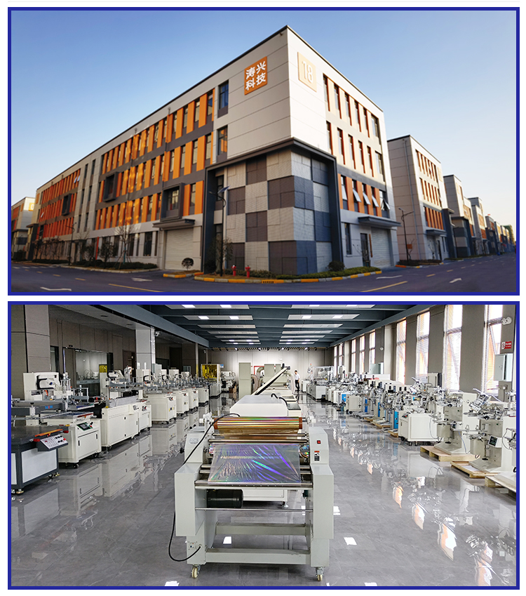
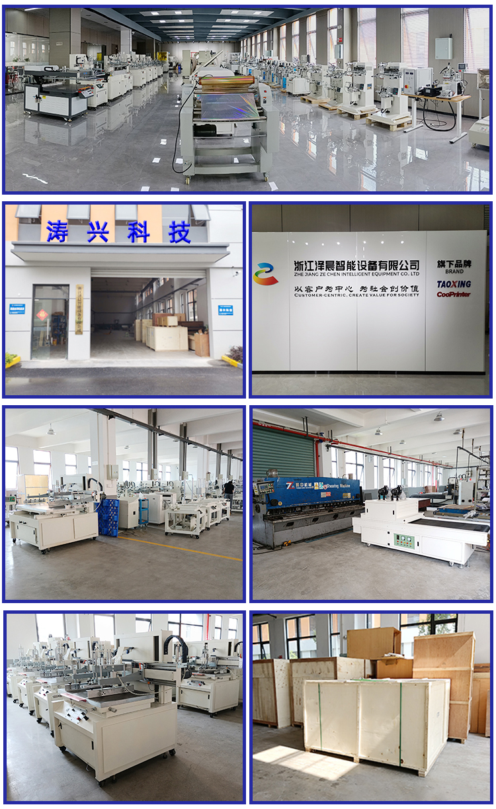
- Company Honors
